Information Technology Solutions

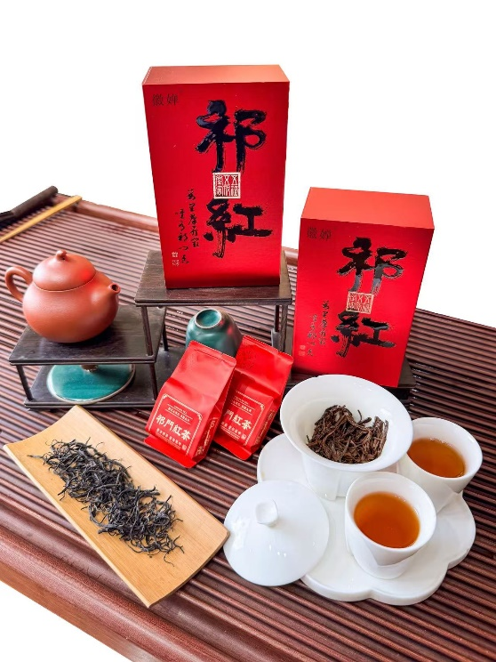

**🍃** Keemun Black Tea – Red Qi Hong Daily Series *The Essence of Qimen, Crafted for Everyday Elegance*

KEY HIGHLIGHTS

* 🌿 Grown in Qimen, Anhui – World-Renowned Tea Region
* 🏆 Gold Medal, 1915 Panama Expo
* 🍯 Signature "Qimen Aroma": Floral, Honey, Fruity
* 🔐 Batch-Tracked & Export-Ready
* 🤝 OEM & Private Label Available

ORIGIN & CRAFTSMANSHIP

* 🌫️ Terroir: Grown at 30°N in misty mountains, 1,700mm rainfall, 85% forest cover
* 🌱 Variety: Qimen Chuyezhong (one bud, one or two leaves)
* 🛠️ Process: Withering → Rolling → Fermentation → Slow Drying
* 🏆 Heritage: Part of China’s Intangible Cultural Heritage (2008)

DID YOU KNOW?

Keemun was a favourite of Queen Elizabeth II’s afternoon tea.

The unique ‘Qimen aroma’ is so distinct, it’s often described as ‘tea perfume.’

**🌿 The Red Qihong Daily Series**

A perfect balance of authentic Keemun character and everyday value, this series brings the classic taste of Qimen to daily tea lovers without compromise.

Sourced from the core Qimen tea region along the 30th parallel north — a golden belt for tea — the tea thrives in a pristine mountain environment:

* 🌫️ Constant mist and cloud cover
* 🌡️ Average annual temperature: ~15°C
* 💧 Annual rainfall: 1,700 mm
* 🌳 85% forest coverage
* 🌱 Humus-rich, mineral-dense soil

These conditions create tea leaves of exceptional depth, fragrance, and smoothness.

**🌏 Origin & Legacy**

Keemun Black Tea (Qimen Hongcha), often called the "Champagne of Teas," is one of the Three Great Highly-Aromatic Teas of the World, alongside India’s Darjeeling and Sri Lanka’s Uva.

First crafted in the mid-19th century in Qimen County, Anhui Province, Keemun gained global acclaim when it won a Gold Medal at the 1915 Panama World Exposition. In 2008, its traditional production method was recognized as part of China’s Intangible Cultural Heritage.

Favoured by British royalty as a key component of afternoon tea, Keemun is celebrated for its distinctive "Qimen aroma" — a complex blend of floral, honey, and fruity notes that lingers with elegance.

Nanjing Nathan International Trade Co.Ltd.

南京芈敦国际贸易有限公司

**🍃 Craftsmanship: Tradition Meets Precision**

Made from the Qimen Chuyezhong tea variety, with plucking of one bud, one or two leaves, this tea follows the full traditional process — enhanced with modern quality control.

1. Withering  
   Leaves are spread and aerated under controlled humidity and temperature, allowing natural moisture loss and aroma development.
2. Rolling  
   Gently rolled to break cell walls, releasing essential oils and preparing the leaves for fermentation.
3. Fermentation  
   Carefully monitored in a climate-controlled environment to ensure full oxidation of polyphenols, creating Keemun’s signature rich, rounded flavours.
4. Drying  
   Slow-roasted over low heat to lock in fragrance and preserve nutritional value.

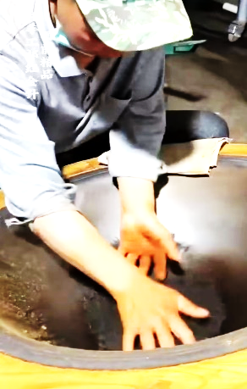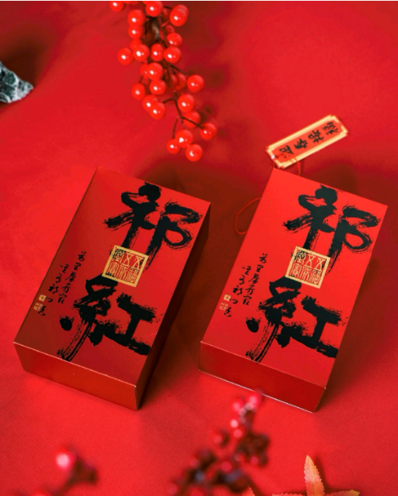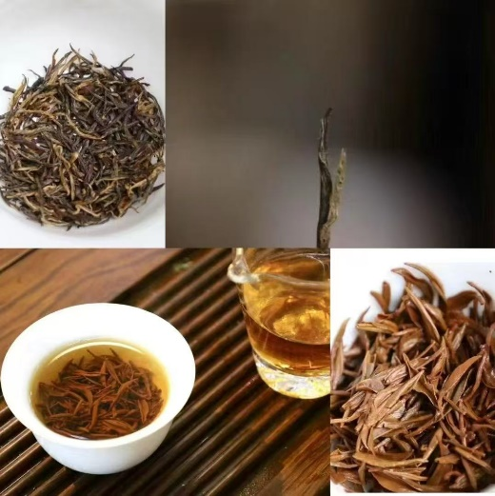

PRODUCT PROFILE

|  |  |
| --- | --- |
| Type | Fully fermented black tea |
| Origin | Qimen County, Anhui Province |
| Aroma | Floral, honey, fruity (“Qimen Fragrance”) |
| Liquor | Bright amber red with golden rim |
| Taste | Smooth, rich, sweet entry, long aftertaste |
| Brewing | 3–5g, 90–95°C, 3–5 sec first steep |
| Packaging | Foil pouches, gift boxes (on request) |
| MOQ | 100 boxes |
| Lead time | 3 – 7 days |
| Price | Negotiable on qty ordered |
| Data sheet | Cert. of authenticity available |

For the perfect cup:

* Leaf: 3–5g
* Water: 90–95°C (194–203°F)
* First Infusion: 3–5 seconds
* Subsequent Steeps: Gradually increase steeping time
* Steeping: 3–5 infusions

Ideal for:

* Afternoon refreshment
* Morning ritual
* Moments of quiet contemplation

Whether you're powering through your workday or unwinding on the weekend, the Red Mao Feng Daily Series delivers authentic Keemun charm at an accessible price.

南京芈敦国际贸易有限公司

Nanjing Nathan International Trade Co.Ltd.

WHY THIS TEA STANDS OUT

* 🌱 Grown in Qimen’s core heritage zone
* 👐 Hand-processed using traditional methods
* 🔍 Batch-traceable from farm to pack
* 📦 Available in retail and bulk packaging
* 🤝 OEM & private label options available

WHY CHOOSE US?

✅ Sole Distributor – Direct from Qimen

✅ Quality Assured – Batch-traceable & tested

✅ Flexible Options – OEM, private label, bulk

✅ Global Shipping – FOB Origin – Huangshan

📞 Contact Us  
Nanjing Nathan International Trade Co., Ltd.  
📧 [salesmanager@nnit.online](mailto:salesmanager@nnit.online)  
📱 WhatsApp: +86 15061517604  
🌐 [nnit.online](https://nnit.online/)

Taste Profile

How to Brew

* Appearance: Tightly twisted, fine, dark leaves with subtle golden tips.
* Dry Aroma: A captivating blend of honey, fruit, and flowers — the iconic "Qimen fragrance".
* Liquor: Bright amber-red with a golden rim.
* Taste: Smooth, full-bodied, with a sweet, clean entry and long-lasting, refreshing aftertaste.
* Aroma in Cup: Delicate floral notes unfold with each sip.
* Wet Leaves: Soft, even, and bright red — a sign of expert processing.