DEEP EARTH CONSULTING JOHANNESBURG PTY LTD

Supplements list for sale:

**JACK HAMMER SUPPLEMENTS**

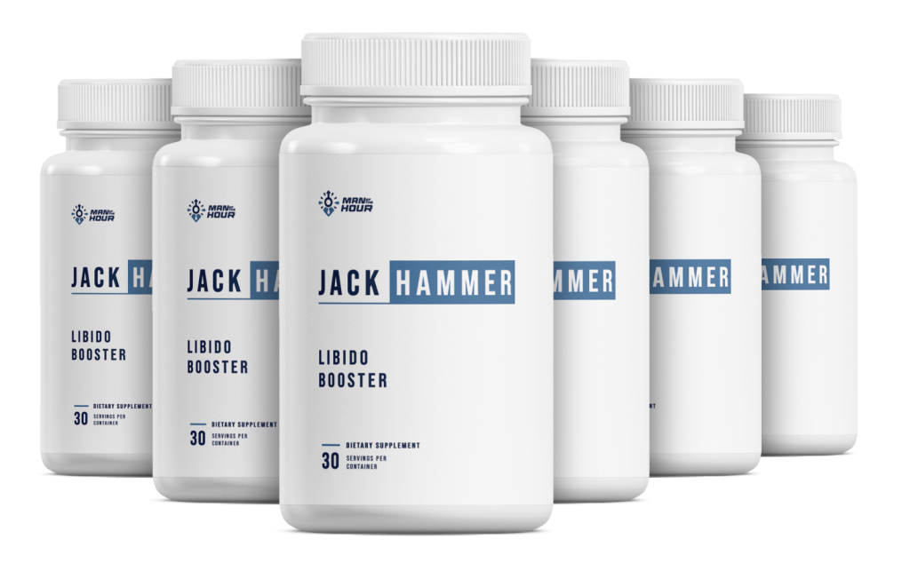

<https://a7156kvoi9ep2n67lcwhoc-t7h.hop.clickbank.net/>

NEURO CALM SUPPLEMENTS

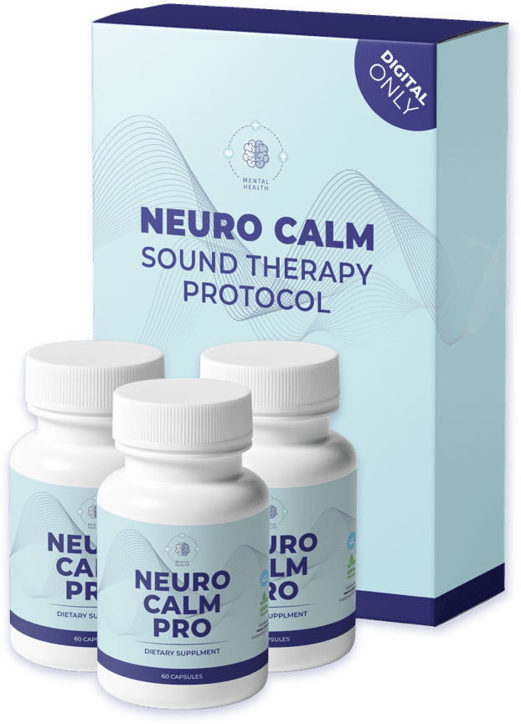

<https://a7156kvoi9ep2n67lcwhoc-t7h.hop.clickbank.net/>