

Mining consultants, Logistics Management, Clearing & Forwarding, Import / Export
P.O.BOX: 1581 CN CANTONMENT ACHIMOTA ACCRA GHANA
Email: adumasemine@gmail.com: Phone: +233 540485857

Our Ref : AU/ADUMASE/GH-00225 Your Ref:................... Date: 10th APRIL, 2025

ATTENTION:

I, Mr. Thompson Asare, with Full Legal and corporate responsibility and under penalty of perjury, as seller am ready, and able to deliver the herein offered 500Kgs of gold under the following terms and conditions.

FULL CORPORATE OFFER

COMMODITY SPECIFICATIONS

- COMMODITY: Gold Dore (AU)
- FORM: Gold Dore bars
- Purity: 96%
- Fineness: 22.45 Carats
- QUANTITY 500 Kilograms
- ORIGIN GHANA
- PRICE: $ 57,000 per kg
- ASSAY: Initial assay to be done at the seller’s Government or private certified testing facility and final assay to be made at the Buyer's registered Refinery and this value will be accepted by both Buyer and Seller.
Procedure:

- Shipment: by air (CIF) to the buyer’s destination according to Ghana government regulation concerning gold export proposal. The buyer will pay to seller shipping agent for the export cost and trial shipment of 100kg and monthly delivery of 500kg contract will be signed with buyer after successful delivery of the trial shipment to buyer refinery.

- FOB: In an event that the buyer decides on FOB, he shall be provided prove of funds before the gold is delivered to the agreed refinery for assay. Furthermore, fob transactions shall be a spot cash and carry. I.E. After assay, the buyer must make cash payment of the value of the gold, and then ownership is transferred into his/her name.

- Documentation: Buyer shall be responsible for the cost of assaying and shipping documents to his refinery being (of the total value 6%) for export documentations to buyer destination.

- Collateral: it is mutually agreed that the seller shall set aside gold as a guarantee for the cost incurred on export documentation by the buyer. This collateral shall be kept by the buyer and seller in a security house as a guarantee with joint signature, in the event that the seller defaults, the buyer shall take this gold to offset his cost. The amount of gold shall be equivalent to the amount advanced.

- Payment Terms: The buyer shall make full payment after final assay to the seller’s designated bank account within 72 hours after assay.

Ownership of Gold
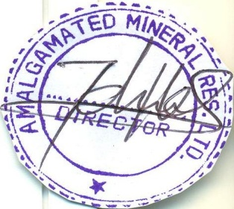
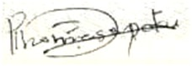
- The Gold will at all times remain the property of the Seller; after receipt of the Assay Report, the Buyer will immediately effect payment to Seller as agreed. Upon Seller’s receipt of full payment of the Gold Bars, the Buyer will immediately take possession of the Gold Bars and then change of ownership.
For

(Managing Director). (Sign By Buyer)
(Prince Asare Thompson)

