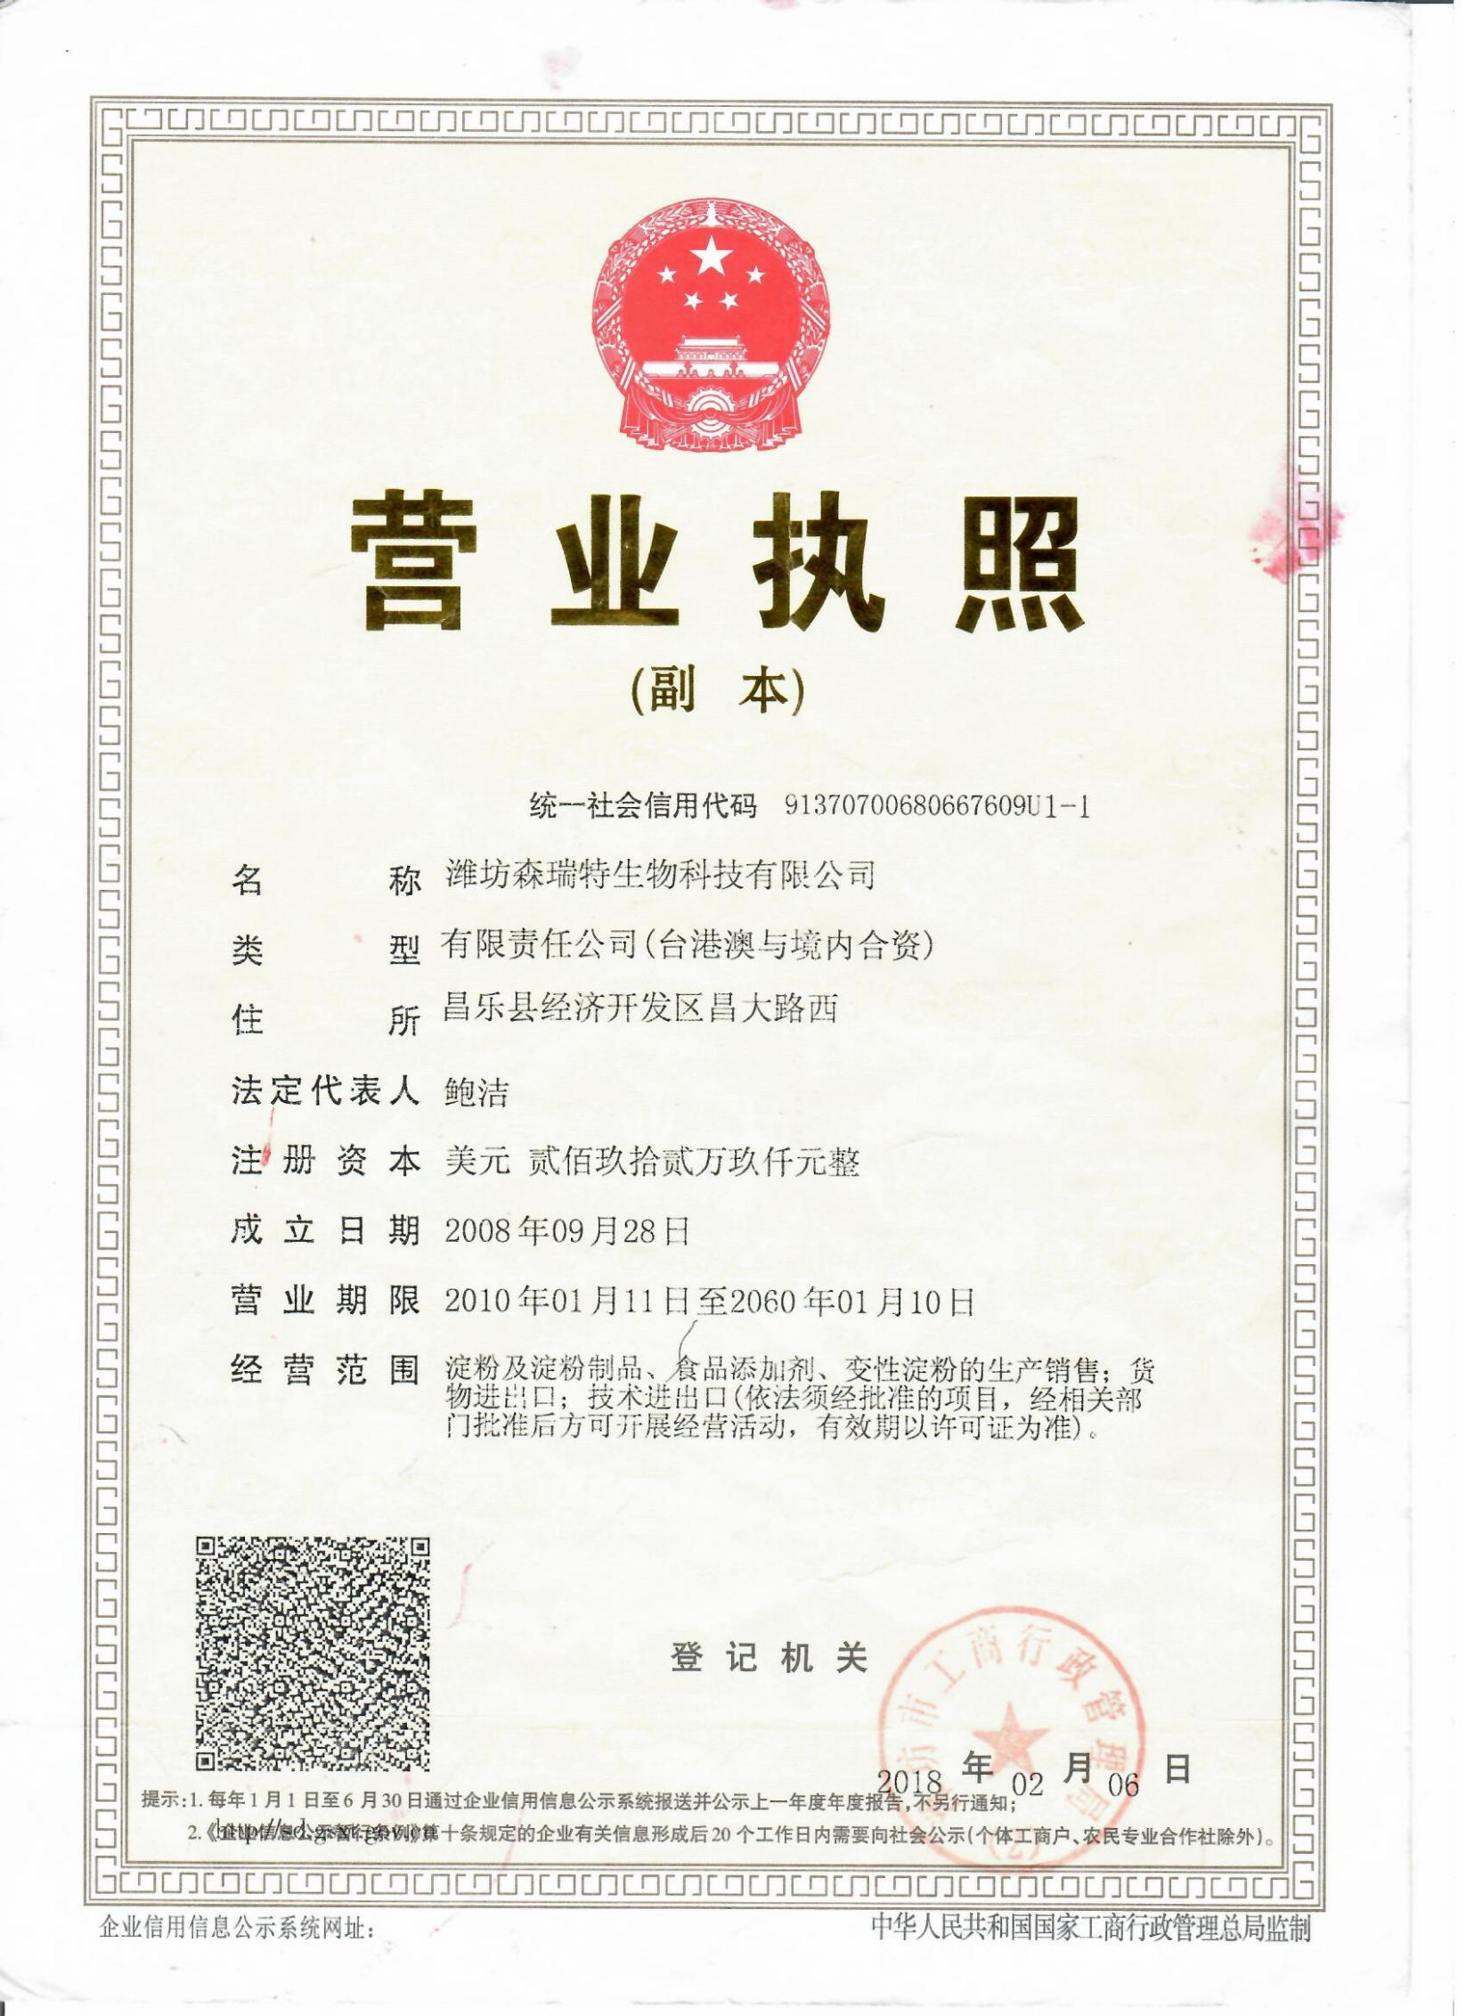

[BUSINESS](https://www.baidu.com/s?wd=BUSINESS&tn=44039180_cpr&fenlei=mv6quAkxTZn0IZRqIHckPjm4nH00T1YvnyN9rHwWujRLPHDLryDL0ZwV5Hcvrjm3rH6sPfKWUMw85HfYnjn4nH6sgvPsT6K1TL0qnfK1TL0z5HD0IgF_5y9YIZ0lQzqlpA-bmyt8mh7GuZR8mvqVQL7dugPYpyq8Q1DYPHczP1nYr0" \t "http://zhidao.baidu.com/_blank) [LICENSE](https://www.baidu.com/s?wd=LICENSE&tn=44039180_cpr&fenlei=mv6quAkxTZn0IZRqIHckPjm4nH00T1YvnyN9rHwWujRLPHDLryDL0ZwV5Hcvrjm3rH6sPfKWUMw85HfYnjn4nH6sgvPsT6K1TL0qnfK1TL0z5HD0IgF_5y9YIZ0lQzqlpA-bmyt8mh7GuZR8mvqVQL7dugPYpyq8Q1DYPHczP1nYr0" \t "http://zhidao.baidu.com/_blank)

**Unified Social Credit Code:** 91370700680667609U

**Name [of](https://www.baidu.com/s?wd=of&tn=44039180_cpr&fenlei=mv6quAkxTZn0IZRqIHckPjm4nH00T1YvnyN9rHwWujRLPHDLryDL0ZwV5Hcvrjm3rH6sPfKWUMw85HfYnjn4nH6sgvPsT6K1TL0qnfK1TL0z5HD0IgF_5y9YIZ0lQzqlpA-bmyt8mh7GuZR8mvqVQL7dugPYpyq8Q1DYPHczP1nYr0" \t "http://zhidao.baidu.com/_blank) Enterprise:** WEIFANG CENTURY-LIGHT BIOLOGY SCIENCE CO.,LTD.

**Character [of](https://www.baidu.com/s?wd=of&tn=44039180_cpr&fenlei=mv6quAkxTZn0IZRqIHckPjm4nH00T1YvnyN9rHwWujRLPHDLryDL0ZwV5Hcvrjm3rH6sPfKWUMw85HfYnjn4nH6sgvPsT6K1TL0qnfK1TL0z5HD0IgF_5y9YIZ0lQzqlpA-bmyt8mh7GuZR8mvqVQL7dugPYpyq8Q1DYPHczP1nYr0" \t "http://zhidao.baidu.com/_blank) [Business](https://www.baidu.com/s?wd=Business&tn=44039180_cpr&fenlei=mv6quAkxTZn0IZRqIHckPjm4nH00T1YvnyN9rHwWujRLPHDLryDL0ZwV5Hcvrjm3rH6sPfKWUMw85HfYnjn4nH6sgvPsT6K1TL0qnfK1TL0z5HD0IgF_5y9YIZ0lQzqlpA-bmyt8mh7GuZR8mvqVQL7dugPYpyq8Q1DYPHczP1nYr0" \t "http://zhidao.baidu.com/_blank):** Limited Liability Company (Taiwan, Hong Kong, Macao and domestic joint ventures)

**Address:** Changda Road West, Changle Development District, Weifang Shandong China.

**Legal Representative**:Bao Jie

**Registered Capital:** Two Million Nine Hundred and Twenty-Nine Thousand US Dollars

**Founded Date:** SEP. 28, 2008

**Operation Period:** From JAN.11, 2010 To JAN. 10, 2060

**BUSINESS SCOPE:**

Starch and starch products, food additives, starch production and sales; import and export of goods; import and export of technology (projects subject to approval can only be carried out after approval by relevant departments, and the validity period is subject to the license)

Industrial and Commercial Administration Bureau of Weifang City

FEB.06,2018