

**ALL VARIETIES OF FOOD GRAINS AND FOOD PRODUCTS AT BEST PRICE**

**IN TIME DELIVERY AS PER DEMAND!!!!!!**

**MADE AFFORDABLE AND AVAILABLE FOR THE BUYERS**

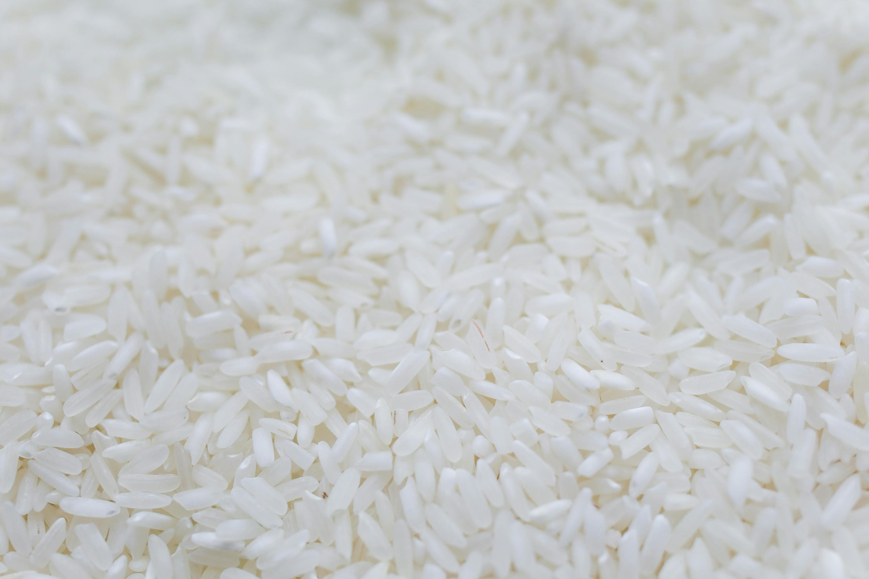 **SPREADING INDIAN TASTES TO THE WORLD!!!!!!**

**FOR ANY TRADES**

**Mr Shreyans Chopra 9769193597 *(Call and Whats App)***

 **Mr Hardik Shah 9664000998 *(Call and Whats App)***

**CONTACT DETAILS**

**BDF INTERNATIONAL LLP**

**C/U/126 , Mahavir CHS, Shankar lane, Kandivali West, Mumbai, 400067**

**Mail: [bdfinternationalllp@gmail.com](mailto:bdfinternational@mail.com)**

**Registration no India: ABBFB4863A(IEC and PAN**

**GST no India: 27ABBFB4863A1ZT**

**RCMC/APEDA/02552/2023**