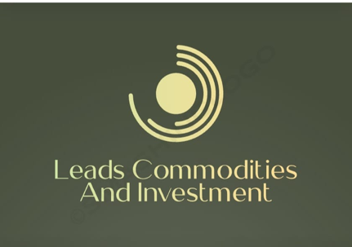

[leadscommoditiesandinvestment@gmail.com](mailto:leadscommoditiesandinvestment@gmail.com) Phone: +23279306999

Hello Timothy

Here is the list of the minerals we mine and please note, what we are doing is artisan mining

**AVAILABLE MINERALS**

|  |  |  |
| --- | --- | --- |
| **NO** | **MINERAL ORE** | **DESCRIPTION** |
| 1 | Platinum Group  Metals (PGMs) | Platinum Group Minerals (PGMs) comprises of Rhodium, Platinum, Palladium, Osmium and Iridium |
| 2 | Coltan | Coltan also known as Tantalite  Contains Niobium |
| 3 | Lithium | Contains both Lepodilite and Spondueme Lithium |
| 4 | Heavy Mineral  Sands (HMS) | Contain Zircon, Rutile also known as Titanium  Dioxide, Ilmenite, Monazite etc |
| 5 | Limestone | For cement and construction industry |
| 6 | Tin | Important alloy |
| 7 | Gold | Gold is mined in dust and nugget form |
| 8 | Diamond | Transparent and colored stones |

**NOTE:** These minerals are available for supply and their concessions are also available for partnership mining project.

Jeff I. Ndzughul

CEO