**LARA FASHION**

**GLOBAL FASHION PRODUCTION**

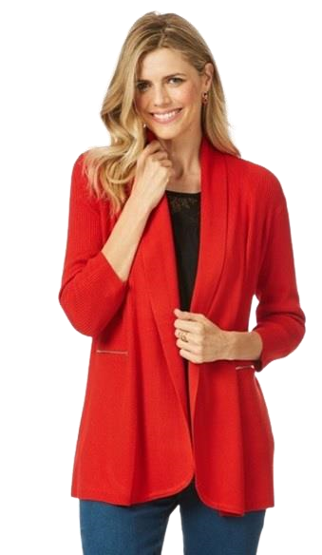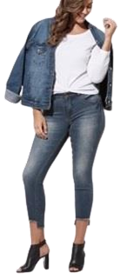

Dear Business Partners

Taking the opportunity to introduce you to our company’s perception. We cordially welcome you to **LARA FASHION.**

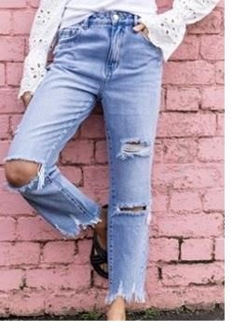LARA FASHION has been established since 2006. Since then, we have produced some gorgeous ethically traced garments for many brands and our customers include all over world.

We are very passionate about our earth. In today’s global economy the protection of the environment is a key component of any sustainable business plan. Reversing, Global warming, climate change, damage to the ozone layer and the loss of biodiversity, solely falls as our responsibility and we are taking key steps in ensuring we do our part.

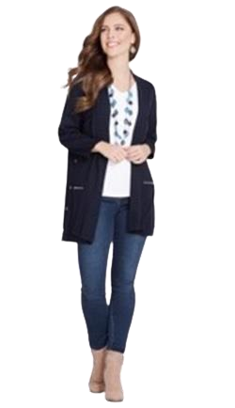All our manufacturing partners are the best of the best in Denim Basic 5 pockets pants, Joggers, T shirts and Sweaters and cut and sew. We are conscious of the cottons we use and ensure full traceability. We can trace the cottons straight to the farm on every single order we produce. We take pride in understanding our customers’ needs and wants when it comes to quality, fiber, fit and price sensitivity.

Our partner all factories are LEED Certified Green Garment factory. They are specialist in recycled denims & regularly producing for leading brands around the world.

Our cut and sew factory partners are 100% green listed factory and awarded number one in sustainability around the world.

We have learnt to adapt to our customers’ needs and business models, and as such would love the opportunity to put our foot in the door and prove ourselves as a solid business partner in manufacturing.

# Our beliefs

* Philosophy based on style, fashion & global trends
* Achievement of business partner goals with full

Satisfaction

* Provide best prices with best excellence

o Ethical business clarity

o Ready to change the views with global trends

# Objectives

To endure our growing path enthusiastically in the fast fashion industry, our company has decided to focus on investing regularly in the research of new resources & design developments only to keep our customer satisfied. We are upgrading our sampling & design team with trendy equipment's based on the changing fashion world.

## THE GROWING NUMBERS

Our annual

turnover is

Million

25

usd

2.9

million

pcs

sweater

0.5

Million

Pcs

Denim

1.6

Million

Cut &

Sew

1

Million

Pcs

Woven

Joggers

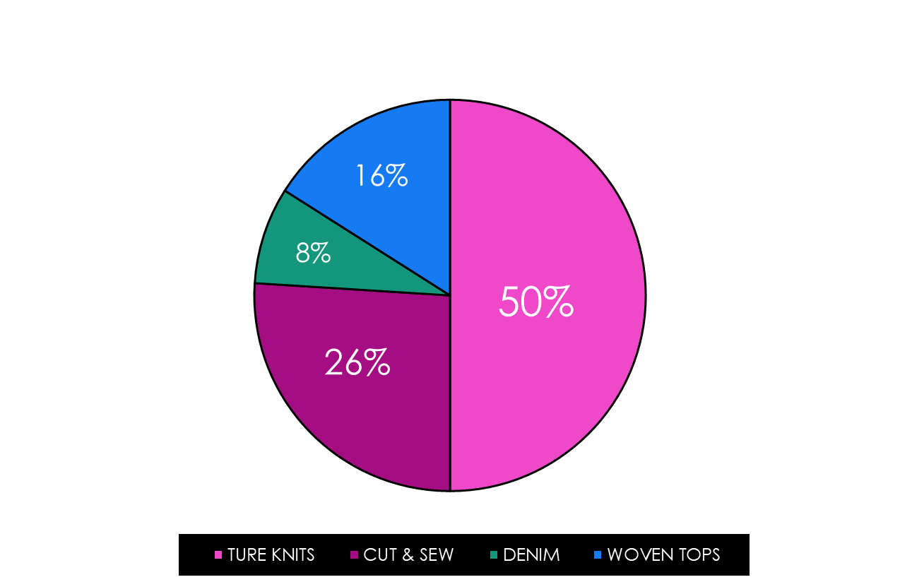

OUR PRODUCT RANGE

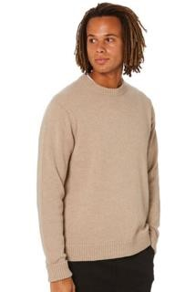

## Our product

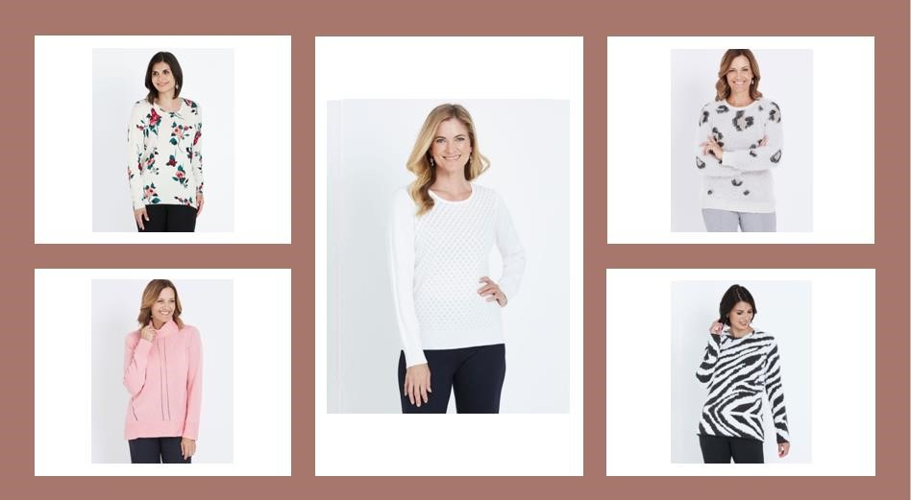

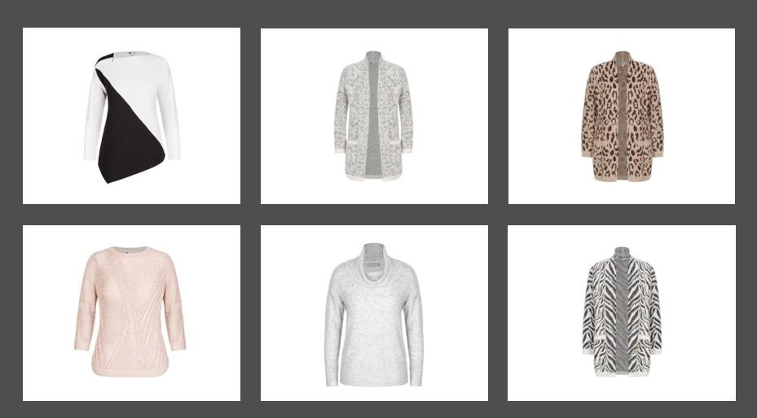

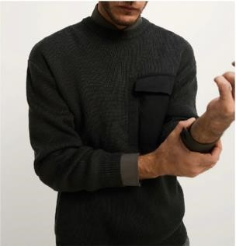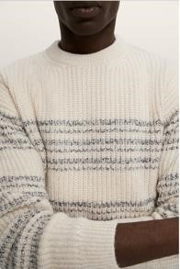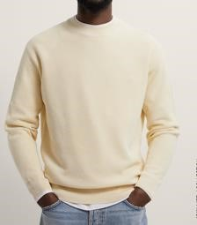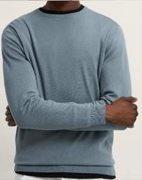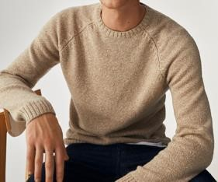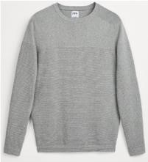

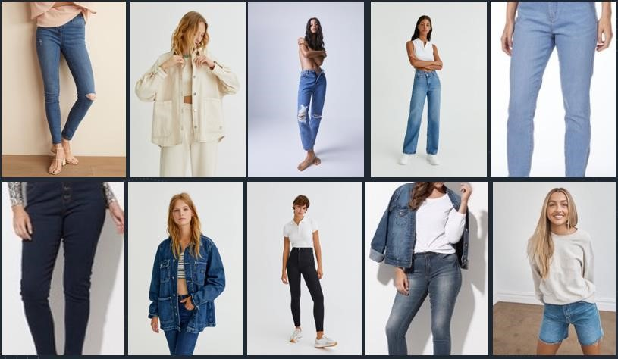

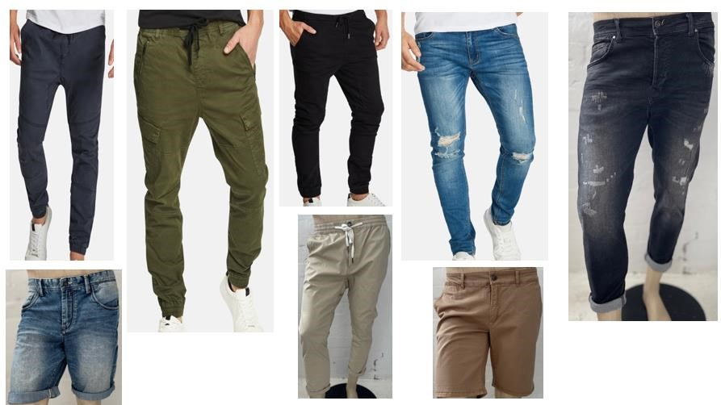

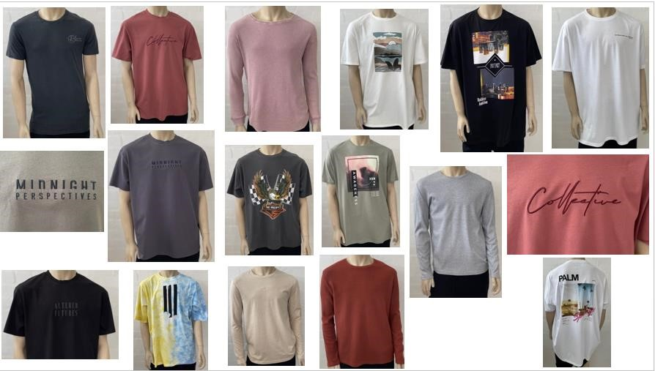

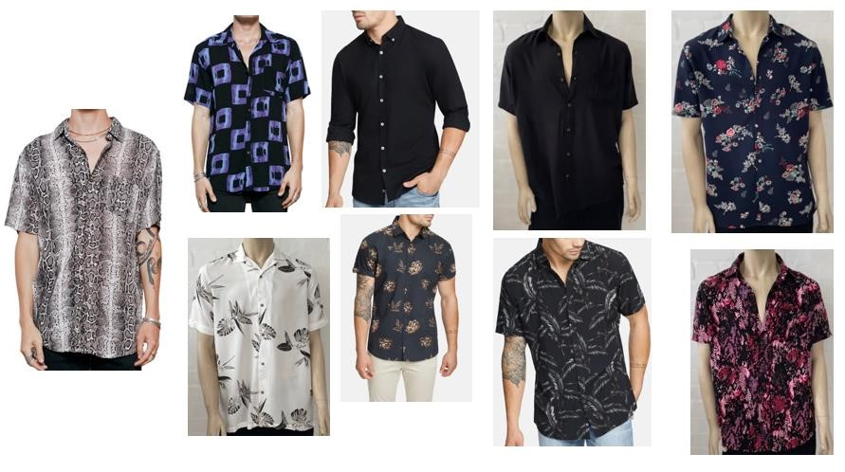

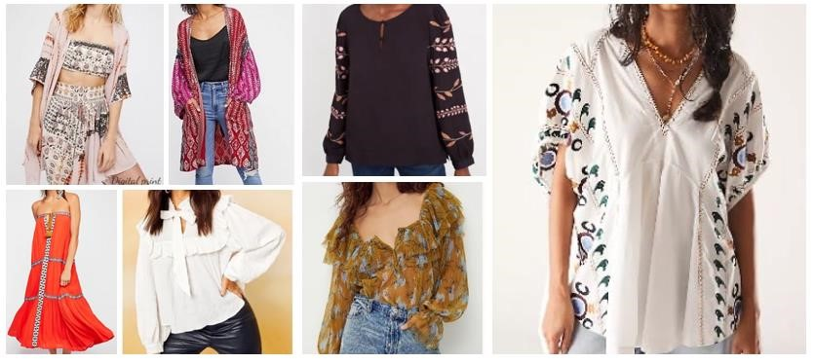

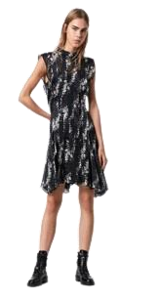

**Office**

**Address:**

**Lara Fashion**

**House #123(2nd floor),Road#03, Block-A,Section #12, Pallabi Mirpur.**

**Dhaka-1216, Bangladesh**

**CEO: Fatima Binte ferdous Lara**

**+**

**Contact person:**

**COO: Maj M A Ferdous (Retd)**

**E – Mail:** [**ferdous@larafashionbdcom**](mailto:ferdous@.larafashionbdcom)

**W/app: +880 13 1212 1616**

**Web: www.larafashionbd.com**

THANK YOU



