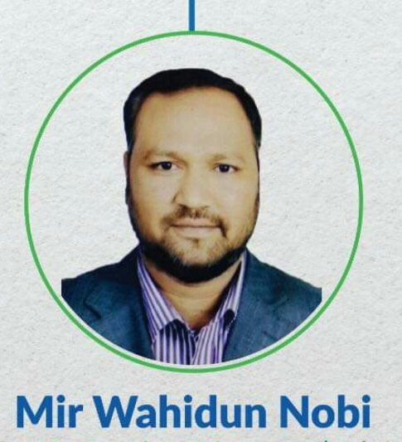

**Curriculum Vitae**

**House : E-9, Road : 7, Mohanagar Project, West Rampura, Dhaka-1219, Bangladesh**

**Summary**

A highly motivated and enthusiastic individual with expertise in management; Has a strong leadership and communication skills; Effective team builder; Proven capability in strategic work; Successful deliverer of profitable growth and cash; Tactically astute in managing a complex supply chain; Innovative sales and marketing skills; pragmatic; hard working; approachable.

**Professional Experience:**

Managing Director, Powerzone Engineering Ltd.,

January 2001 to till this date.

Managing Director, Valley View Developments Ltd.  
January 2011 to till this date.

Working as Senior an Operative Director (Adviser) in Walton Group.

**Responsibilities:**

* Guided the business into the future with planned growth.
* Controlled the financial status of the business.
* Developed business line with stated objectives.
* Determined the company policies with regard to quality, health and safety and the environment.
* Undertook the role of management system representative ensuring that management system is implemented reviewed, maintained and where possible continually improved.

**Education**

**Master of Commerce (Accounting)**National University of Bangladesh, 1996, 2nd Class

**B.Com (Pass)**

National University of Bangladesh, 1994, 2nd Class

**HSC (Commerce)**

Dhaka Education Board, 1992, 2nd class

**SSC (Arts)**

Rajshahi Education Board, 1990, 2nd class

**Post Graduate Diploma in Development Planning** under Planning ministry, 1999.

Course Completed.

**Skills:**

* Excellent command of the English language
* Organization Skills
* Written and verbal communication
* Interpersonal skills
* Relationship-building skills
* Innovative approach

**Personal Information**

**01. Name :** Mir Wahidun Nobi

**02. Father’s Name :** Mir Nurul Huda (Late)

**03. Mother’s Name :** Syeda Suraiya Begum (Late)

**04. Permanent Address :** Village: Karatipara, Post: Karatia, P.S.: Bashail, District:Tangail

**05. Nationality :** Bangladeshi

**06. Date of Birth :** 2nd December 1975

**07. Marital status :** Married

**08. Religion :** Islam

**09. Height :** 5 -10.5

**10. Weight : 80 kg**

**Blood Group : A+**

**10. E-Mail :** **powerzone2001@gmail.com**

**Contact Cell No : 008801670049191**

**Signature**

**Mir Wahidun Nobi**