**PROFILE**

***ECHO PRODUCTION AND ETERTATINMENT AND TRADING***

**“BUILDING THE EMPIRE OF ARTS”**

**WHERE YOUR DREAM BECOMES REALITY**



5235 NEWSTACE

DEBEERSHOOGTE

BARKLEY WEST

CELL: +27(73)295 2705

EMAIL@ [MOSIMANE.JACOBS@YAHOO.COM](mailto:MOSIMANE.JACOBS@YAHOO.COM)

**ORGANIZATION DETAILS CONTACT DETAILS**

**Name and surname : Mosimane M Jacobs**

**Physical Address. : 5235 NEWSTANCE**

**: Debeershoogte**

**: Barkley west**

**: 8375**

**Telephone number. : 078 462 6259**

**Cell phone number. : 073 295 2705**

**Fax number. : N/A**

**E-mail address :** [**mosimane.jacobs@yahoo.com**](mailto:mosimane.jacobs@yahoo.com)

**Contact person. : Mosimane M Jacobs**

**Organisation legal status. : Registered**

***Table of content***

1. ***Company background***
2. ***Objective***
3. ***Mission***
4. ***Core value***
5. ***Services***
6. ***Previous work***
7. ***Business details***
8. ***Contact details***
9. ***Company registration documents***

## ***Company certificate***

* 1. ***CIDB certificate***
  2. ***Tax clearance certificate***

1. ***Identification of owner***
2. ***Proof of banking***

*PROFILE*

1. **INTRODUCTION**

ENCO PRODUCTION AND ENTERTAINMENT AND TRADING is a new limited liability company formed under the strict laws.

This document has been prepared to provide the reader with information about our company, including business structure, company goals, business ventures and the industry trades.

ENCO PRODUCTION AND ENTERTAINMENT AND TRADING is general company that operates in different industries because its business ventures is not limited. Its primary interest is to make sure it serves all clients to the best of their abilities and beyond the client’s expectation. Encho production and entertainment and trading will at all times demonstrate its commitment to sustainability, both individually and as a business, by making sure we walk an extra mile to meet our clients’ needs and render a great service and also by integrating sustainable business practices wherever possible. We make sure that we hold ourselves accountable to the highest standards by meeting our client’s needs precisely and completely.

Encho production and entertainment and trading is owned and managed by Mosimane Jacobs. Mosimane Jacobs has experience in Business Management for coupled of years. His’ hands on and experienced in business.

Mosimane Jacobs, founder of Encho Production and Entertainment and Trading has observed, “Clients are not just interested in buying things but they also want great service. They want an experience, adding that the keys to providing successful experiences are authenticity and professionalism. Quality service is a focus of ENCO PRODUCTION AND ENTERTAINMENT AND TRADING.

### **2**. **Objectives**

The company’s objective is to build a reliable company with great service. The company that meets all client’s needs. The services that will command the approval of the predominantly clients which it serves.

**3. Mission**

To grow a business that strive excellence service, quality products and competitive prices, while exceeding all its stake holders’ expectation. We will help to reduce crime by alleviating poverty by creating employment for the less privileged.

4. **Core value**

To build a better business that provide worthy business solution whiles respecting the confidentiality of our clients business operation

**5. Our** **Services**

***General supply Cleaning service Construction***

* Office furniture and equipment gardening bricklaying & roofing
* Building material tree and grass cutting fencing
* Stationary office cleaning plumbing
* Cleaning material painting
* Crockery and cutlery Paving & tarring road
* Electrical supplier Tiling
* And many more welding
* Protective clothing installation of water
* And sewerage pipes

**Events management and organizing**

* Catering
* hospitality
* transportation
* Maintenance and repair

That was just to name few of our services but we do more than that, anything you want we can do and give.

***Previous job done***

Catering for frances baard business forum

Catering for department of health national event

Supply health covid package for dikgatlong municipality woman’s day.

Supply sanitizers for dikgatlong municipality.

***Previous project done***

Sub contracted at Rooi rand primary school Build block C and D classes.

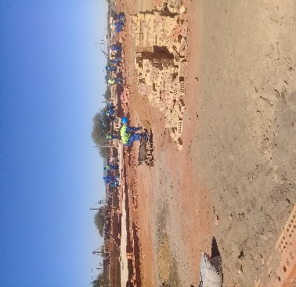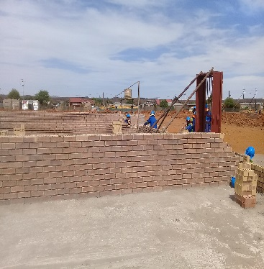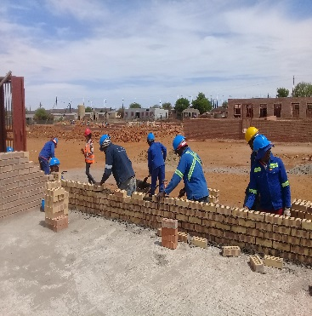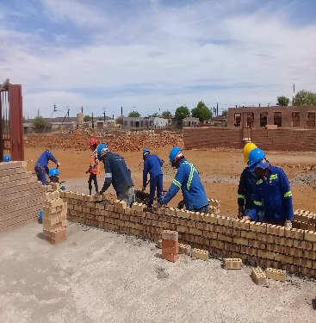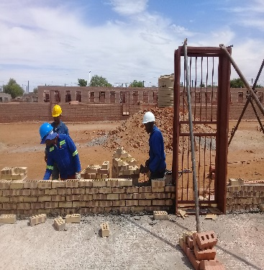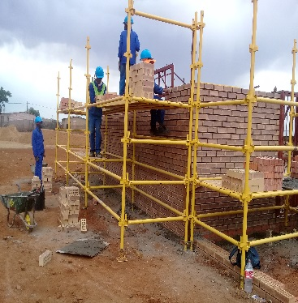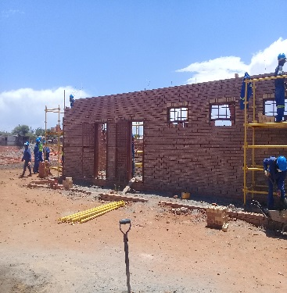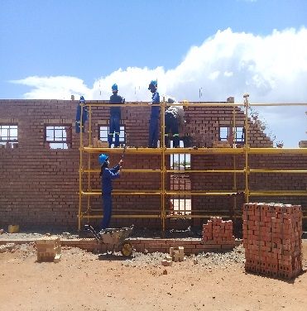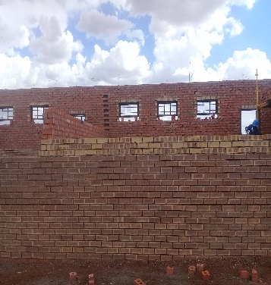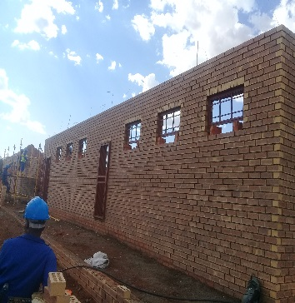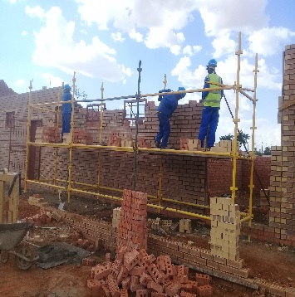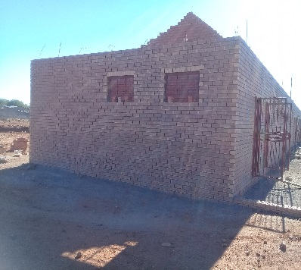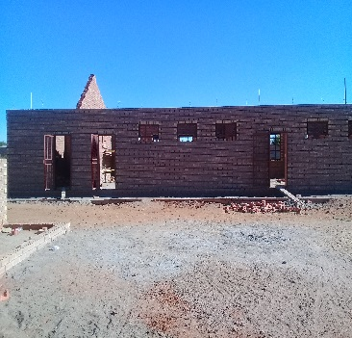

6. ***BUSINESS DETAILS***

Company name Encho production and entertainment and trading

BEEE: LEVEL 1

CIDB: Grade 1 CE-PE

CRS NO: (10134023)

Supplier number MAAA0485367

SHAREHOLDING 100%

Type of business (PTY.LTD)

Registration number 2013/156228/07

7.**Contact details**

Contact person Mr Mosimane M Jacobs

Contact 073 295 2705

Email address [mosimane.jacobs@yahoo.com](mailto:mosimane.jacobs@yahoo.com)