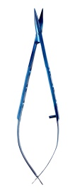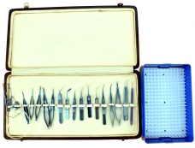\* Cataract Set with IOL Implantation Set Titanium

Set of 19 Instruments Rs. 25000/-

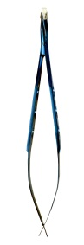\* Scissor conjuntival universal curved

JT-242 Rs. 3850/-

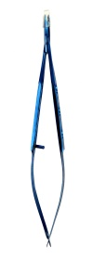\* Scissor corneal universal curved

length100mm JT-244 Rs. 3800/-

\* Scissor corneal straight overall length 100mm

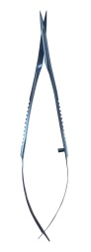 JT-246 Rs. 3500/-

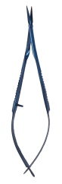\* Scissor vannas straight overall length 95mm

JT-248 Rs.4100/-

\* Scissor Vannas Curved overall length 95mm

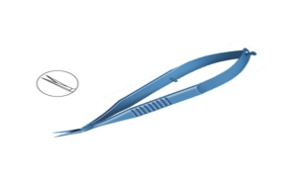 JT-250 Rs.4100/-

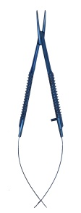\* Scissor Veannas Angle upward capsulotomy

overall length 95mm JT-252 Rs.4200/-

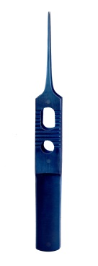\* Needle Holder Baraquer without lock curved

overalllength 113mm JT-254Rs. 3800/-

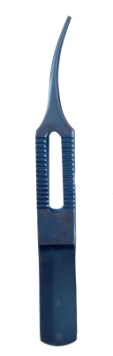\* Forcep tying straight with platform,

overall length 87mm JT-256 Rs. 1500/-

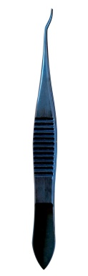\* Forceps tying curved with platform

overall length 87mm JT-258Rs. 1550/-

\* Lims Forceps 0.12mm/0.2mm, 1x2 teeth with

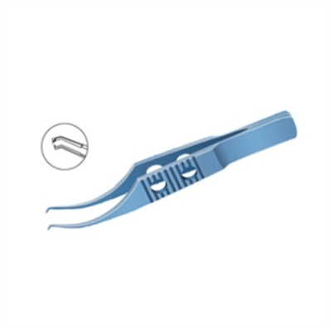tying platform overall length 93mm. JT-260 Rs.1600 /-

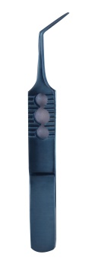\* Colibri Forceps 0.12mm, 1x2 teeth with tying

platform overall length 83mm JT-262 Rs.1550/-

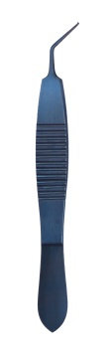\* Forceps McPherson angled 12mm with platform

overall length 85mm JT-264 Rs. 1600/-

\* Forcepscapsulorhexis straight overall length 85mm

JT-266 Rs.3200/-

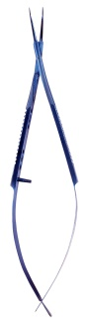\* ForcepsHaldipurkarcapsulorhexis overall length 110mm

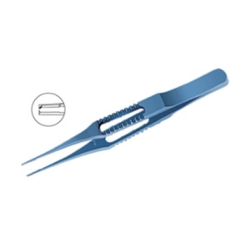 JT-268 Rs. 3500/-

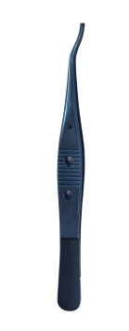\* Corneal Forceps toothed 0.12mm1x2 tee th with tying

platform overall length 87mm JT-270 Rs.1400/-

\* Forcep superior rectus toothed

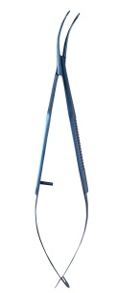overall length 115mm JT-272 Rs. 1450/-

\* Shepard lens holding forceps with serrated

lower jaw gently curved shanks overall

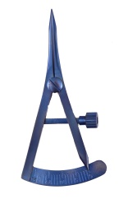size120mm JT-274 Rs.2100/-

\* Castroviejo Calliper, 20mm spread singhle/double

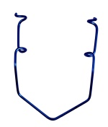graduatedoverall size 75mm JT-276Rs.3500/-

\* Kratz-Barraquer Wire Speculum with

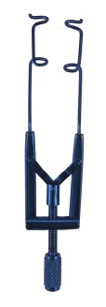open blades for unobstructed access

to the cataract incision adult/child JT-278 Rs. 350/-

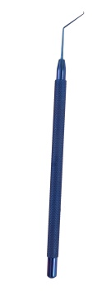\* Speculam adjustable spread for phaco/

lasik overall size 82mm JT-280 Rs.1800/-

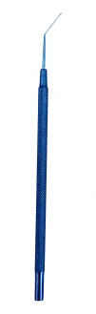\* Sinsky hook extra fine single ended

overall length 123mm JT-282 Rs.1050/-

\* Spatula single ended

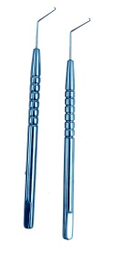overall length 123mm JT-284Rs. 1050/-

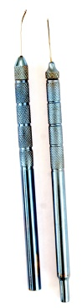\* Phaco chop blunt/sharp1mm chopping edge single ended

overall length 115mm JT-286Rs.1200/-

\* Bi-manual irrigation/aspiration hand piece 21G

overall length 115mm JT-288Rs.600/-

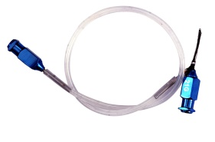\* Simcoe Irrigation & aspiration Cannula

with silicon tubing. 23 guage, 22g, 21g, 0.3mmdia

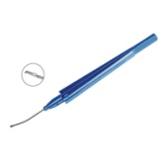 JT-290 Rs. 1200/-

Capsulorshexis Forcep 23 gauge Curved Shaft with

micro grasping tip JT-300 Rs. 4800/-

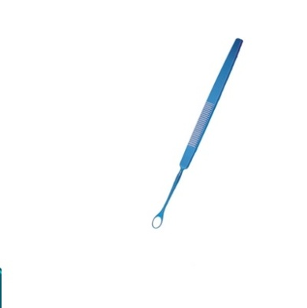Lense Loop (Vectis) Overall length 140mm JT-302

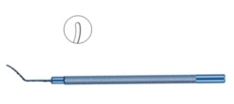Rs. 1100/-

Repositor single ended malleable overall lenght 123mm

JT-304 Rs. 1050/-