**Product name**: Sorghum Grains

**Submitted By**: Sandesh Birajdar

**Company Name**: SAGASHKA International Exports

**EPC**: Agricultural and Processed food Products Export Development Authority (APEDA)

([http://www.apeda.gov.in/](http://www.cashewindia.org/))

**Hs code**: 1007900 (Whole Sorghum Grains)

**INTRODUCTION:**

Sorghum is a cereal grain that’s widely produced around the world. Its whole grain is commonly used in baking, while its syrup is used as a sweetener. Finally, it’s used as a natural fuel source.

* Jowar grown for grain should be harvested when it attains physiological maturity.
* Dry ear heads promptly as moisture content influence keeping quality.
* Avoid pest infestation during drying and threshing etc.
* Dry the jowar grains sufficiently (below 9 percent) prior to packing and storing.
* Jowar seeds should be dried in diffused sunlight in sun.
* Pack the jowar in jute bags free from infestation and obnoxious smell.
* Avoid harvesting during adverse weather conditions i.e., rains and overcast weather.
* Harvesting should be done by adopting proper method

**PRODUCERS:**

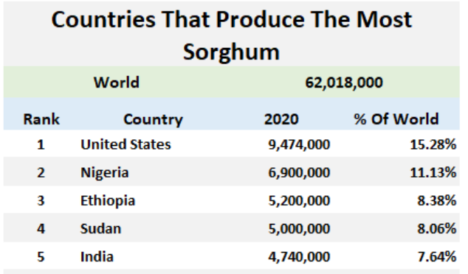

**PRODUCT SPECIFICATION AND GRADES:**

**Shelf life**: 12 months

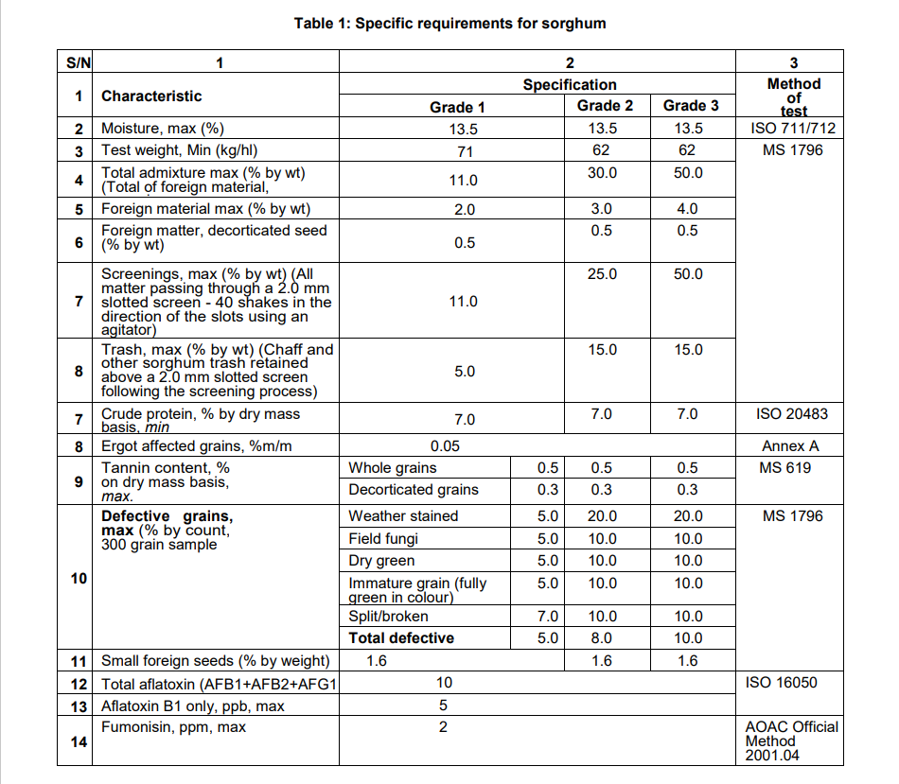

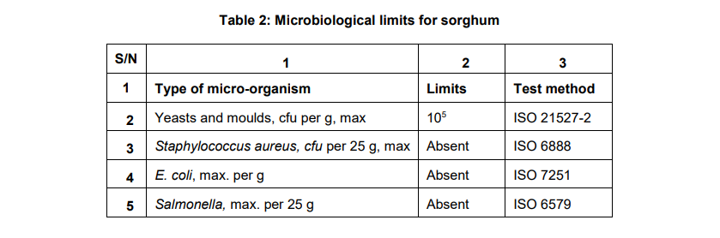

# HEALTH BENIFITS:

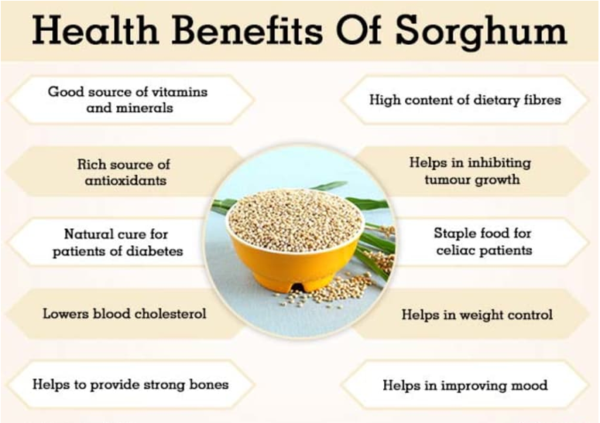

**NUTRITIONAL ANALYSIS: Nutritive Value in 100 g of Sorghum Grains**

Sorghum is an underrated, nutrient-rich cereal grain. Half a cup of uncooked sorghum (100 grams) provides:

|  |  |
| --- | --- |
| Total Minerals | 2.4 |
| Total Fiber | 7 |
| Energy | 329 |
| Protein | 10.4 |
| Total Fat | 3.1 |
| Carbohydrate | 70.7 |
| Ash (g) | 1.6 |
| Crude fibre (g) | 2.0 |
| Ca (mg) | 25 |
| Fe (mg) | 5.4 |
| Thiamin (mg) | 0.38 |
| Riboflavin (mg) | 0.15 |
| Niacin (mg) | 4.3 |

Sorghum is also a good source of the following micronutrients:

* Vitamin B1 (thiamin)
* Vitamin B6
* copper
* iron
* magnesium
* phosphorus
* potassium
* selenium
* zinc

**IMPORTER**: (2021) source: https://[www.trademap.org/Country](http://www.trademap.org/Country)

1. Kenya
2. Sudan
3. Kuwait
4. Pakistan
5. Saudi Arabia
6. Egypt
7. Nepal
8. United Arab Emirates
9. Spain
10. Canada

**EXPORTER:** (2023) source: https://www.commerce.gov.in

1. Egypt
2. Canada
3. India
4. U Arab Umts
5. U S A
6. Oman
7. Kuwait
8. Germany
9. Japan
10. Netherland

**USES:**

Sorghum is versatile and easy to add to a number of recipes.

The following are some ways you can enjoy it:

* **Replace rice or quinoa.**You can cook whole grain and pearled sorghum much like you’d cook [rice and quinoa](https://www.healthline.com/health/food-nutrition/quinoa-vs-rice).
* **Milled flour.**Thanks to its neutral flavor and light color, it can serve as a [gluten-free flour](https://www.healthline.com/nutrition/gluten-free-flours) in most recipes. Simply swap it in at a 1:1 ratio.
* **Popped.** Add the grains to a heated pan and watch them pop like popcorn. Add seasonings for extra flavor.
* **Flaked.** Similarly to other cereal grains like [oats](https://www.healthline.com/nutrition/rolled-vs-steel-cut-oats), flaked sorghum is delicious as a cereal and in baked products, such as [granola bars](https://www.healthline.com/nutrition/healthy-granola-bars) and cookies.
* **Syrup.** Sorghum syrup is commonly added to processed foods as a natural sweetener or an alternative to molasses

**Availability of packaging material**:

Jowar is packed in the bags of following material:

1. Jute bags

2. H.D.P.E./P.P. Bags

3. Polythene impregnated jute bags

4. Cloth bags for seed

Qualities of good packaging material:

* It should be convenient in operations.
* The packaging material must preserve the quality of produce.
* It should be convenient to stack.
* It should be able to prevent spillage during transit and storage.
* It should be cost-effective. 9 It should be clean and attractive.
* It should be biodegradable.
* It should be helpful in reducing the marketing cost by reducing the handling and retailing cost.
* Packing material should be reusable.

**PRICES IN DOMESTIC MARKET**: (approximate prices)

Avg. Price: 4500.00-5000.00 INR/Quintal

# PRICES IN INTERNATIONAL MARKET:

# Avg. Price: