Company Profile
Company Name | CV Asiateak Furniture
Managing Director | Mr. Ronny Arifulbillah
Address | Desa Langon, Tahunan, Jepara, Central Java, Indopnesia
Telephone / WA | +62-813-2424 2834
Email | agungmuliya@gmail.com
Website | www.rattanmeuble.com
Contact Person | Mr. Ronny and Mr Cipta
Product | Furniture made from rattan, teak and mahogany wood, natural fiber and synthetic fiber, accessories such as basket, mirror, racks from natural fiber pr synthetic fiber.
Capacity | 20 x 40 ft
Employee | 50
Establishment Date | 2018
Export Destination : | Turkey, India, Russia, UK, France, and Worldwide
Bank | CIMB Niaga  USD Account : 8000 2273 4540  Bank Address : Jl. Siliwangi No. 110 Cirebon 45123 , Indonesia
Product Image
Chairs | 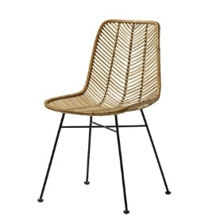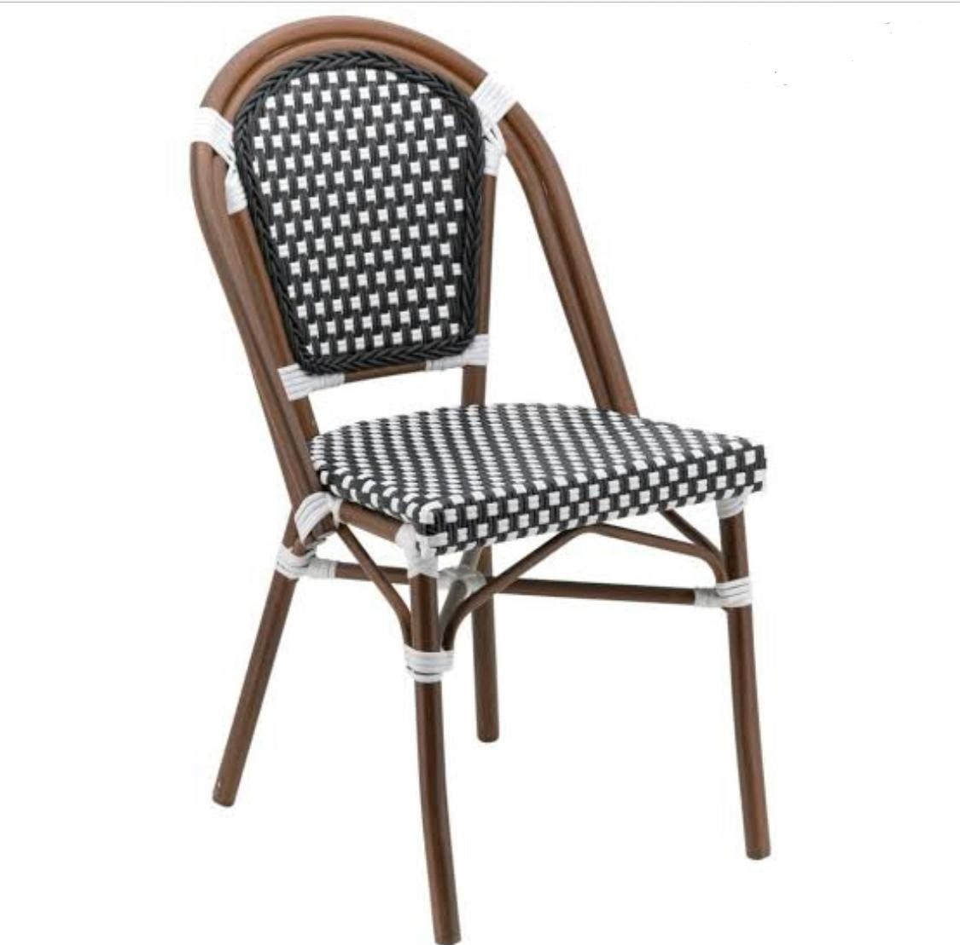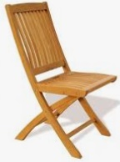
Dining | 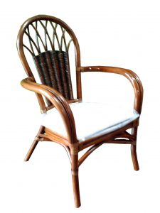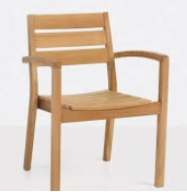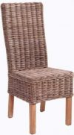
Living | 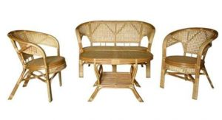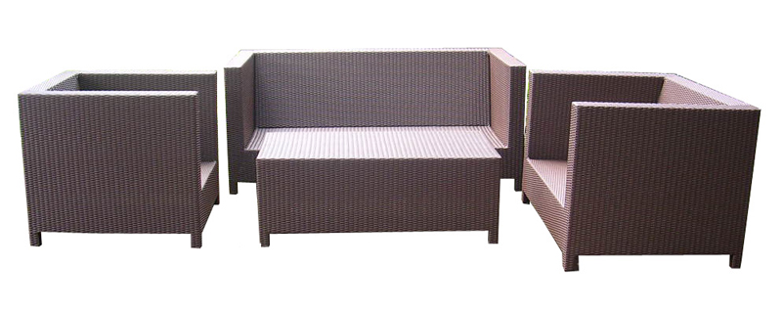
Ocassional | 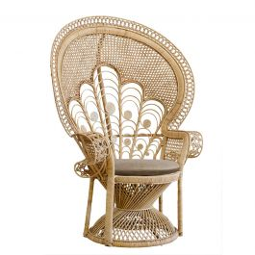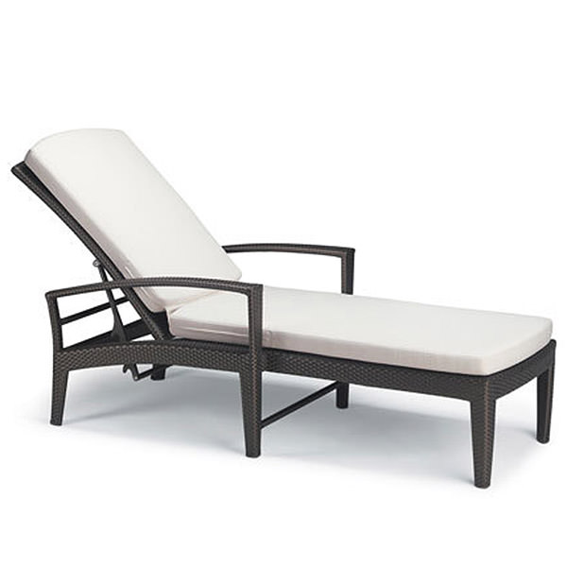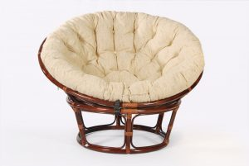
Accessories | 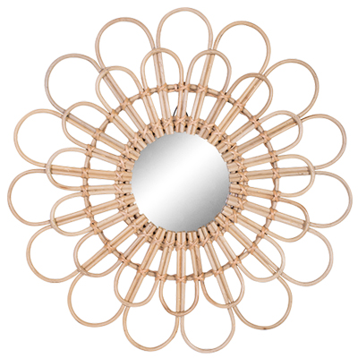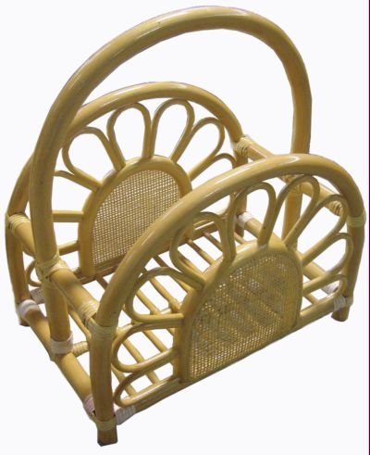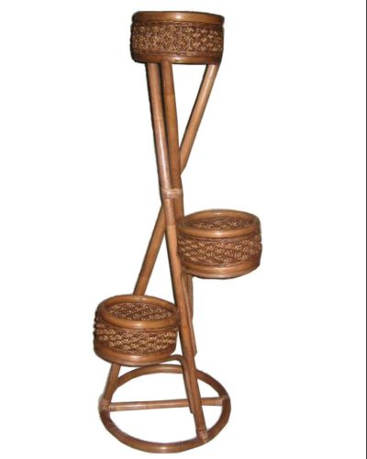
Factory | 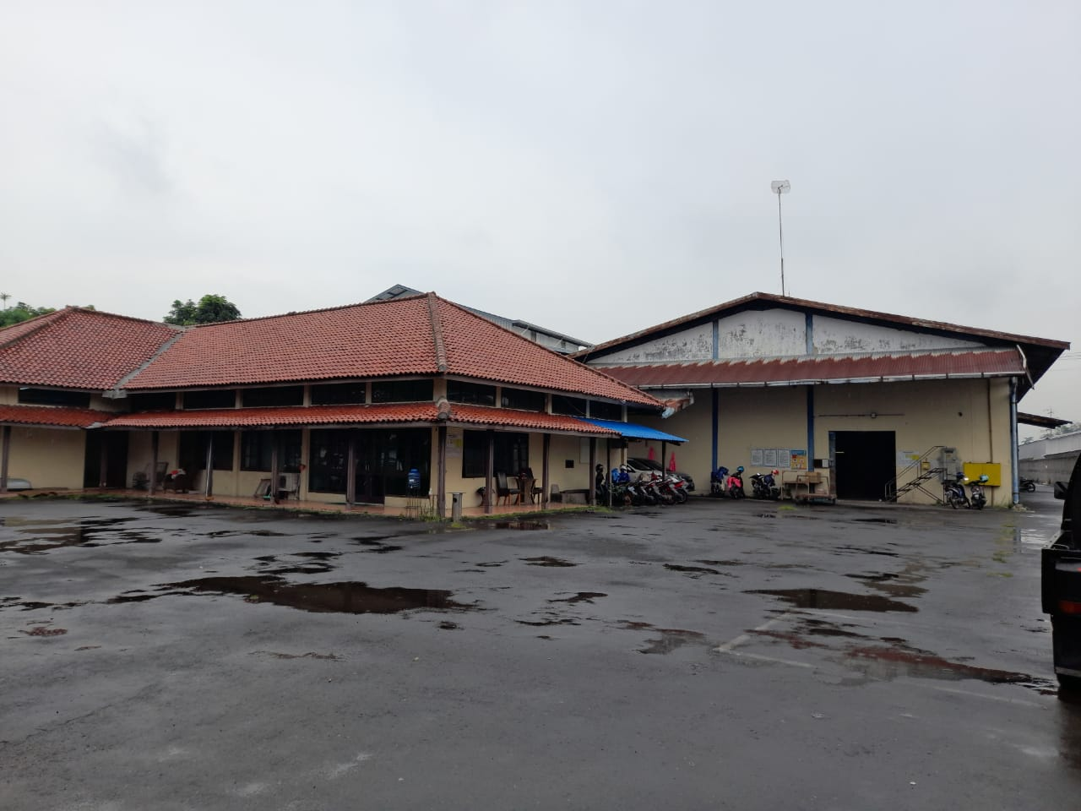
 | 