MALIGAHENA INTERNATIONAL
PURE AGRO BASED PRODUCTS
&
EXPORTERS, SRI LANKA

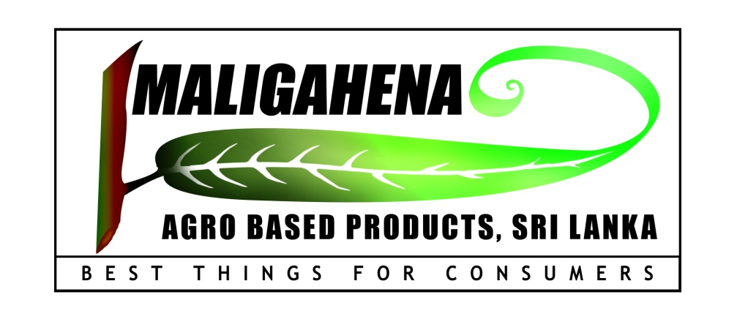

Address :-
MALIGAHENA WALAWWA,
MALIGAHENA ESTATE,
KAHANGAMA, RATNAPURA
SRI LANKA
maligahenaagrobase@yahoo.com
maligahenaagro@bellmail.lk

CONTENT

- INTRODUCTION

- GENERAL INFORMATION OF PLANT

- HEALTH BENEFIT OF PLANT / GENERAL

- HOME REMEDY FOR HEALTH PROBLEMS / GENERAL

- BUSINESS PAGE

01.INTRODUCTION
Botanical Name : Cinnamomum Zelanicum Blume (Ceylon Cinnamon/True cinnamon)
Family : Lauraceae
Origion : Knuckles rang of forest in upcountry area, Sri Lanka
Cinnamoum is a tropical evergreen plant. it is a resist to broad climatic conditions and growing in various soil condition including specially in lateritic soil in Sri Lanka. But most well growing in low country, wet zone in Sri Lanka Ratnapura, Galle, Matara and Kalutara District and Negambo areas in the country. But most favorable growing condition in Ratnapura District.
The cinnamon Industry in Sri Lanka maintain Several years is being a traditional industry in the country. During the period of 12th to 14th centuries Arabian sellers knew that true cinnamon coming from Ceylon and it is recognized as superior. In 1505 potuguses invaded the coastal areas of sri lanka. they maintained the cinnamon trading and began to its cultivation which is a sri lankan (Cinnamomum zelanium Blume) Origion of the plant. Cinnamon is the third largest export agricultural crop of Sri Lanka and provides 80 - 85% of the world demand of pure cinnamon. Over average fifteen thousand metric ton of Ceylon Cinnamon is annually exported to Latin America, USA and Other Europian countries.
Our company introduced cinnamon quills to export market as a Sri Lankan products of pure Ceylon cinnamon (under the gradeing proccess) are as it is guaranteed a Hygienically proven products and truly effective dietary products and healthy maintain human body with high medicinal values.Mostly cinnamon quills are producing in our factory as early harvested materials just prepared for packing process are very freshly to the market. In additionally we bought cinnamon materials from local market in the area and these materials manufactured (grading) again in our factory in hygienically sound. Our manufacturing facilities are located in maligahena Estate, Kahangama, Ratnapura, Sri Lanka.
02. General Information of Plant :
Ceylon cinnamon has been used as culinary spices and highly introduced medicinal herb for thousand of year. Traditionally, these popular aromatic substances are used to support healthy microbial balance and gastrointestinal function of the body. It is recently introduced it has led to exciting discoveries about its beneficial effect on the body composition, glucose metabolism and cardiovascular function as it is antioxidant.
Cinnamon is long been known as a disinfectant, stimulant and anti-flatulent, but the only medicinal cinnamon is that called the true or Ceylon cinnamon produced in Sri Lanka. Worm cinnamon tea sipped slowly and it is avoided in the event of nausea with take it bed time can be obtained promote sleep.
Quills, Featherings, Chips Dust form, Leaf oil and bark oil. are being produced by this plant but major export products is cinnamon quills which account 90% of the whole industry.

Main chemical Component : Volatile oil
Factors affect the Quality : Soil factor, Cultivation method and processing Techniques.
Suitable weather conditions : Temperature range is 25ºC - 30ºC and annual average Rain fall
between 1875 mm - 3750 mm

03. HEALTH BENEFIT OF PLANT (in general)

- Reducing blood sugar level and treating Type II Diabetes.
- Lowering Cholesterol
- Aiding digestion
- Treating Diarrhea
- Curing the common cold
- Reducing arthritis pain
- Boosting memory and cognitive function
- Treating toothaches
- Eliminating bad breath
- Curing headaches and migraine pain
- Reducing Blood cholesterol level.

05 BUSINESS PAGE/COMPANY PROFILE

- Business Name Maligahena International Pure agrobased Products and Exporters,Sri Lanka
Sri Lanka.
- Principal Place of Business No1, Maligahena Estate, Kahangama, Ratnapura, Sri Lanka.
(Cinnamon Plantation) (44 N) 742533 N, 429180 E
Province - Sabaragamuwa
District - Ratnapura
- Address No1, Maligahena Estate, Kahangama,
Ratnapura, Sri Lanka.
- Contact Person B.D.R.A.M.Sarath .Bandara Ranasinghe
- Office email maligahenaagrobase@yahoo.com, maligahenaagro@bellmail.lk
- Telephone +9455674285, +94771955899.+94718300631
- Terms and conditions It Can be discussed with the consolidation of reliability of buyers.
- Description of goods "Cinnamomum Zelanicum Blume"
(Ceylon Cinnamomum/True Cinnamomum)
- Grade of Quills C5 Special, Mixed grades of C4/C5 and H1,H2, M4,M5
- Main markets E.U. Region, Australiya, Newzeland and Middle East Countries
- Management & Sri Lankan Government Authorized Certificates
- Kuruwita Divisional Secretariat Registration of (Sabaragamuwa Province, Ratnapura District) Business - R/Kuru/1560
- Export Development Board, Sri Lanka,-EXPORTCHAMPION-E18050021393
- Ceylon Chamber of Commerce(CCC)/Associate Membership - GS1/1112/21/01
- Intellectual property Reg. - LK/T/1/162360, LK/T/1/16359
- Industrial Technological Institute, Sri Lanka(ITI) – SS1114984
- National Chamber of Export of Sri Lanka – Membership No. 720

- Quantity of Supply minimum supply - 10kg
maximum supply – 500 kg or over

13. Packing method - 50gr (Net) of cut quills ,Sealed Polypropylene Packing in Printed Box included 100 packets of 5kg carton, 1kg Aluminum Covered Cinnamon Ground,

14. Other Cinnamon Products - 10 kg cut Quills Boxes, Cinnamon Leaf 0il, featherings, chips & dust form It can be supplied according to request.
15. Price Can be determined according to present market price & exchange rate.

